Osman Kantarcıoğlu
30891
CS210 Project Step 2

Introduction
The objective of the second phase of the project is to undertake a comprehensive statistical analysis by using two distinct datasets, with the aim of deriving meaningful conclusions. This long journey involves three primary stages: initial exploration and descriptive analysis of the data, hypothesis formulation followed by hypothesis testing, and development of a singular linear regression model for predictive purposes. At the end of these three stages, the goal is to determine if there's a connection between the daily number of new COVID-19 cases and the daily price of Netflix stock.

Exploration and Description of Data
In this study, two distinct datasets were employed to conduct the analysis. The initial dataset, sourced from the CS210 team via Kaggle, pertains to US stock market data spanning the years 2019 to 2024 (accessible at: https://www.kaggle.com/datasets/saketk511/2019-2024-us-stock-market-data?resource=download). Additionally, a supplementary dataset was obtained from Kaggle's repository, focusing on global COVID-19 statistics (available at: https://www.kaggle.com/datasets/aditeloo/the-world-dataset-of-covid19). The utilization of these two disparate datasets formed the foundation of the analytical framework employed in this project.

Supplementary dataset: Data on COVID-19 (coronavirus) is provided by Our World in Data. This data is updated daily.

Columns of Data: This data involves various columns such as iso_code, continent, location, date total_cases, new_cases, total_deaths, new_deaths and others. Most of the columns are in float64 type such as new_cases. On the other hand very little portion of data in object type such as date and location columns. Even though there are so many columns. I only used location, date and new_cases columns.

Location Column: I used location to find daily new_cases in United States because there is 225 unique location value other than United States. However, they do not produce meaningful result because Netflix stock price is from stock market of the United States. As can be seen from the X axis, this axis is overloaded with too many location names.

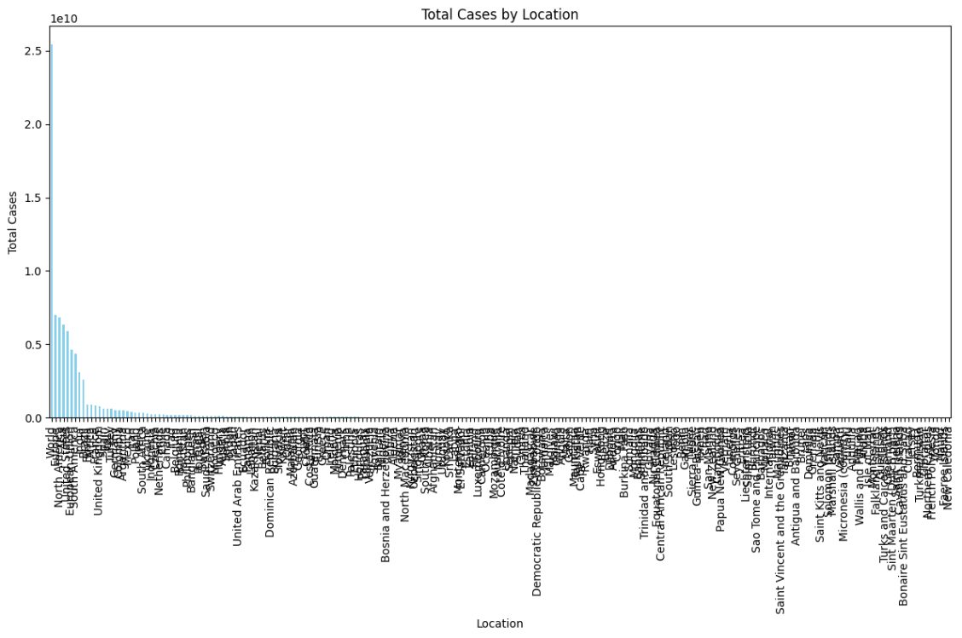

Date Column: This dataset is between 2020/01/22 and 2021/05/24 which is beginning, and the end of the COVID-19 outbreak. On the other hand, “United State Stock Market Data” is between 04/02/2019 and 02/02/2024. As can be seen dates are in different format and they cover different time periods. They were changed to find meaning full result so that they are in the same format and cover the same time period. Firstly, date column of both “United State Stock Market Data” and “The World Dataset of COVID-19” data is transformed to datetime64 data type. After that, “United State Stock Market Data” has been filtered to include only dates between '2020/01/23' and '2021/05/24'. One of the data is from '2020/01/23' to '2021/05/24'. Whereas, other one is from '2021/05/24' to '2020/01/23'. Therefore, “United State Stock Market Data” has been reversed. The scatterplot at the bottom shows date range of “The World Dataset of COVID-19” data.

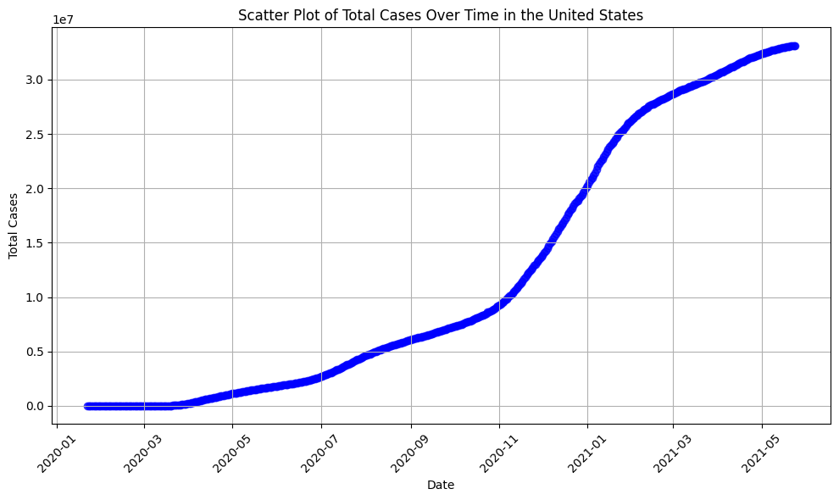

New_case column: The number of new COVID-19 cases reported on the corresponding date is shown in this column. It begins with NaN (Not a Number) for January 22, 2020, which could mean that there is missing data. It then displays the number of newly reported cases each day. Firstly, the number of missing data is checked by using necessary command and reached the conclusion that only first row (January 22, 2020) has missing data. It is inaccurate to fill it in using the data mean since the COVID epidemic started on a specific day. The row has been removed from the data rather than being filled in. The mean of the new_case column is 67917.338115 with minimum new case 0.000000, maximum new case 300310.000000 and standard deviation is 64605.584572. As also can be seen in histogram at the mottom, most data clustered around the 50000 band and also it is easy to see that maximum value is 300000 and minimum value is 0.

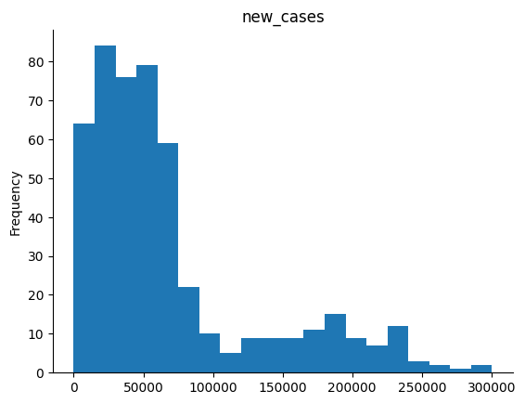

Main dataset: The dataset contains a diverse sectors found within a financial portfolio, including energy commodities (such as natural gas and crude oil), metals (like copper, platinum, silver, and gold), cryptocurrencies (including Bitcoin and Ethereum), and major stock indices and companies (such as the S&P 500, Nasdaq 100, Apple, Tesla, Microsoft, Google, Nvidia, Berkshire Hathaway, Netflix, Amazon, and Meta Platforms).

Columns of Data: This data involves variety of columns such as Date, Natural_Gas_Price, Natural_Gas_Vol., Bitcoin_Price, Bitcoin_Vol. , Netflix_Price Netflix_Vol., Amazon_Price Amazon_Vol., Meta_Price and Gold_Price. Even though there are so many columns just Date and Netflix_Price columns were used to support study.

Netflix_Price Column: This column is just used to get daily stock price of the Netflix.

Date Column: This column is just used to understand which stock price belongs to which day and to combine it with the other dataset.

Formulating Hypothesis and Performing Hypothesis Testing

A few plots were plotted to understand is there any positive and negative corelation between COVID-19 cases and Netflix stock price.

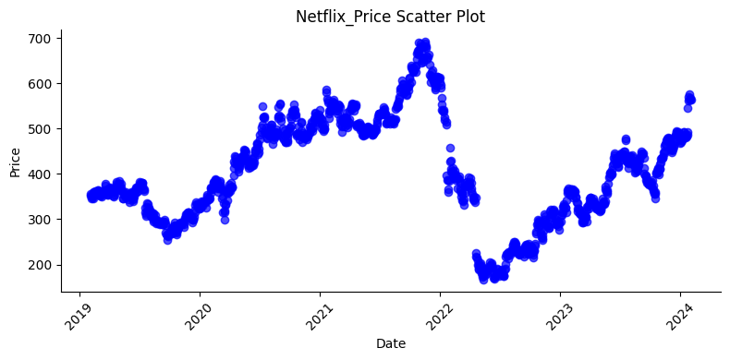

This scatter plot involves all dates (from 04/02/2019 to 02/02/2024) of the “United State Stock Market Data”. It shows that there are increases and decreases for 5 years period which does not produce meaning full result.

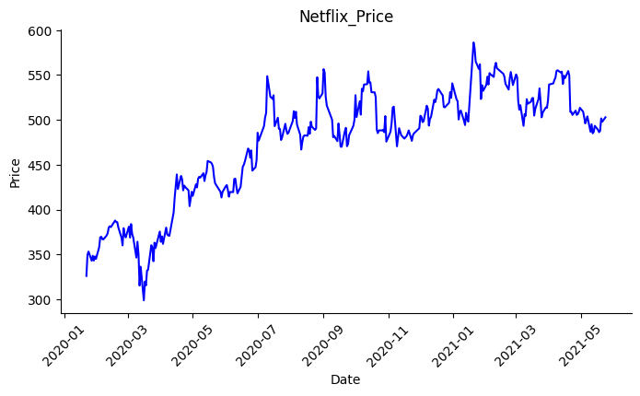

On the other hand, this scatter plot involves the dates of the supplementary dataset “The World Dataset of COVID-19” (from 2020/01/22 to 2021/05/24) which corresponds to beginning and end of the COVID-19 pandemic. As can be seen from the graph stock price in upward (bullish) trend. This trend raises the question of whether there is a correlation between the stock price and the number of new cases.

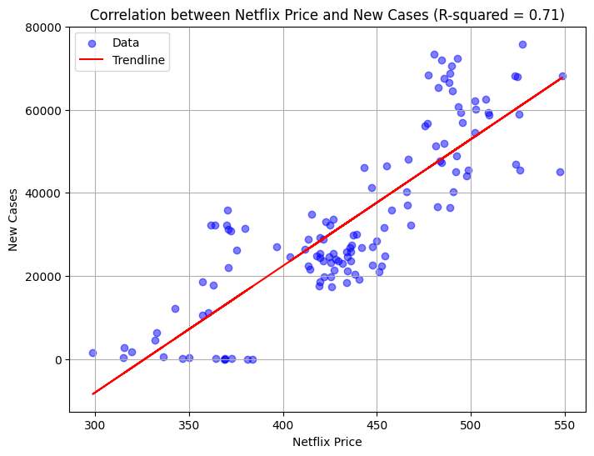
By inspiring from previously drawn two plots, new plot has been formed to understand whether there is a corelation between the stock price and the number of new cases. X-axis of the plot represent Netflx stock price and y-axis of the plot represent number of new cases. Finding Netflix stcok price correcponding number of new covid case required some requires several steps beforehand. Firstly, NaN (Not a Number) values from both “United State Stock Market Data” and “The World Dataset of COVID-19” are deleted. Secondly, after deleting NaN (Not a Number) values from both “United State Stock Market Data” and “The World Dataset of COVID-19” sizes of the datasets (the number of rows) are different. For example, Netflix_price may exist in “United State Stock Market Data” for 24/08/2020 when corresponding new case data does not exist in “The World Dataset of COVID-19” or vice versa. This problem is handled by merging both datasets using inner join on dates. Finally, the scatter plot and trend lined is drawn. R^2 value and distribution of the values on the graph helped me to form the basis of formulation my hypothesis.

Formulation of hypothesis:

The COVID-19 pandemic causes huge fluctuation and economic uncertainties in global stock market after January 2020. Most people stayed indoors and did not go out. While this has negatively affected most companies, Netflix may have been positively affected and this increase in the stock price may be linked to the increase in new_case because people who have seen the high number of infected patients may have decided not to go out and spend time at home and watch movies. That's what we want to understand. Two hypotheses were developed for this.
Null Hypothesis (H0): There is no statistically significant linear relationship between the number of new COVID-19 cases and Netflix stock price.

Alternative Hypothesis (H1): There is a statistically significant linear relationship between the number of new COVID-19 cases and Netflix stock price.

Performing Hypothesis Testing:

Alpha value is set to 0.05 and p value corresponding is fond as 8.798011113274795E-35. The results are considered statistically significant, and the null hypothesis is rejected when the p-value is smaller than the alpha threshold. Therefore, it shows that there is a statistically significant linear relationship between number of new covid case and Netflix stock price.

Build A Single Linear Regression Model For Prediction

Modeling the relationship between one or more independent variables (predictors) and a dependent variable (target) is done statistically using linear regression. It makes the assumption that the predictors and the target variable have a linear relationship.

In the context of the code provided, we trained a linear regression model to predict the Netflix price based on the number of new cases.

Number of new cases (new_cases_series) and the corresponding Netflix prices (netflix_price_series) are used to train the linear regression model.

As can be seen in the plot at the bottom the linear regression line has been drawn and Netflix price for 10,000 new cases has been predicted. According to model, predicted Netflix price for 10,000 new cases is 381.7551263883812.

